

Project Vernon
Registered Charity 1128677
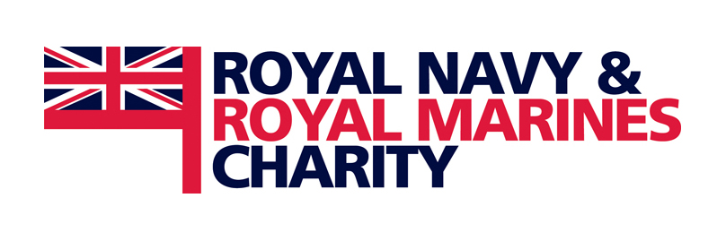

Registered Charity No. 1117794
Registered In Scotland SC041898

Royal Navy Clearance Divers and Friends:

Sponsored 13 mile Swim around Portsea Island 30 July 2011

in aid of Cystic Fibrosis Kids of Portsmouth

RN&RM Charity and Project Vernon

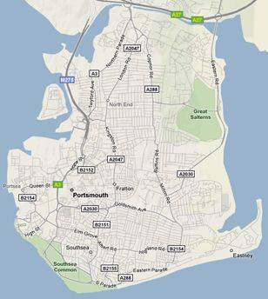
Start/Finish

Each Swimmer will swim the challenging 13 Miles (this is not a relay): please pledge generously!

Name of swimmer / collector: ______________________

Total sum pledged: ______________________________

Name | Contact Details  (Email / Phone / Address) | Pledge  Amount | Postcode | Gift Aid  (Tick) | Paid (Date)

