MCDOA Order Form for ‘Mines over Malta’ by Frederick Galea

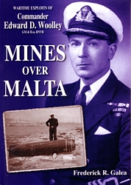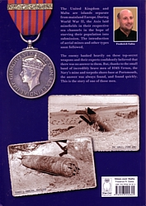

To:

Mark Anthony Vella
Wise Owl Publications
59, Levels 1 & 2
Main Street
Rabat RBT1012
Malta GC

Tel: +356 21453303
E-mail: mavella@wiseowlmalta.com

Please send me ………….. copy/copies of Frederick Galea’s new book, ‘Mines over Malta’, about the wartime Bomb & Mine Disposal exploits of Cdr Edward Woolley GM* RNVR.

My name is: ……………………………………………………………………………..

My address is: ……………………………………………………………………........

……………………………………………………………………………...

………………………………………………………………………………

………………………………………………………………………………

I enclose a cheque for £……………….. @ £11.50 per book plus £3.50 Post & Packing.

