Descent
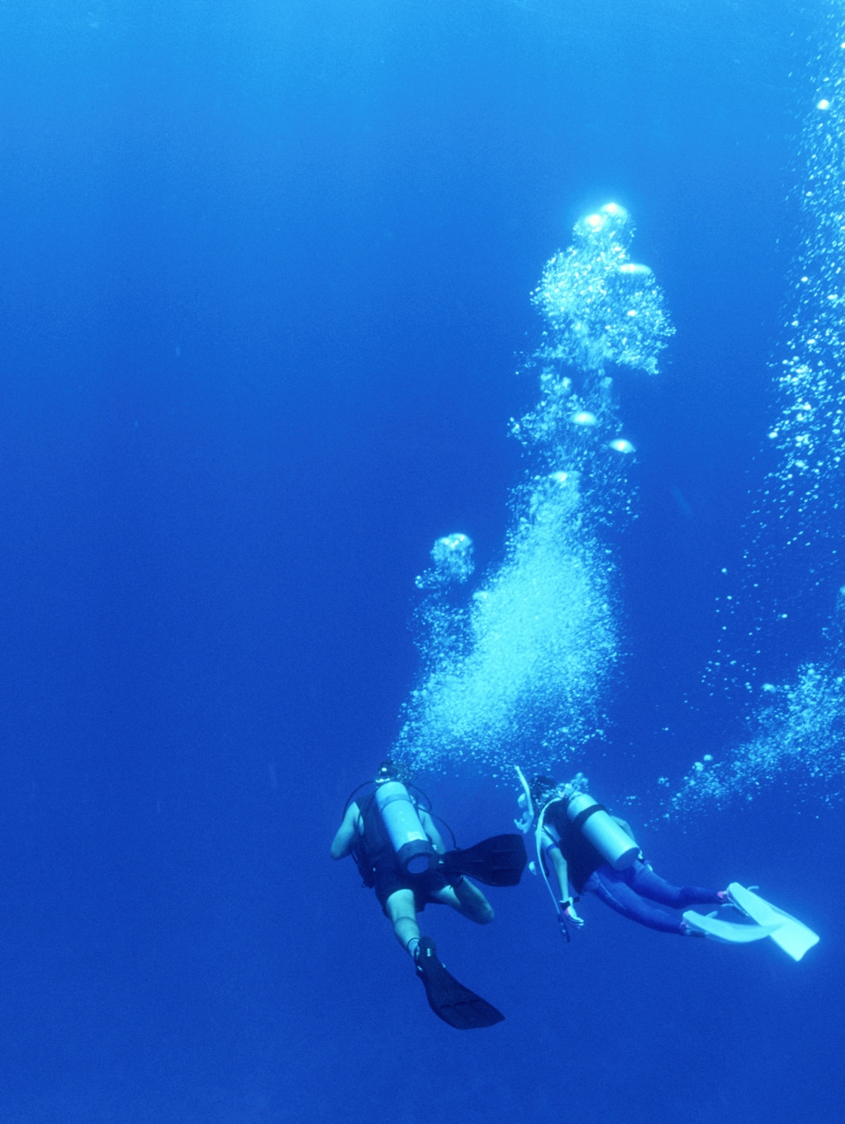

Oh, I have shrugged off the noise and calamity of modern day
and floated through the depths on bubble-glistening fins.
Downward I have drifted and joined the ebb and flow
of wind-driven currents,

and done a thousand things you would never have dreamed of.
Dipping and swooping deep in the limpid pools of silent seas,
Floating…. Drifting….
I’ve chased shimmering schools of fish,
laughed through coral-carpeted canyons,
and eased my rubber-covered body through the floorless oceans of blue.
Deeper and deeper into the bone-chilling depths
I’ve descended to the sand covered bottom of the universe,
with peaceful reserve, where sunshine nor rain have ever danced.
And…. While with silent questioning mind,
I’ve slipped through the blue un-trespassed serenity of the heavenly sea,
Raised up my face

and felt the cool embrace of God

Robert Gwalchmai
Clearance Diver
Canadian Navy

