UK based
MCDOA, AORNFCD & MWA Association Members 5 may 2011

COMBINED ASSOCIATION
2011 SUMMER BBQ & SOCIAL

Summer is nearly here, and as the great space heater in the sky gets closer our thoughts turn to heading outdoors to gather with friends and colleagues to enjoy some fine fare, accompanied by a cool glass of amber nectar. Thankfully the perfect opportunity is again at hand with our combined Annual BBQ and Summer Social on Saturday 11 June at Horsea Island.

The intention is to again enjoy an informal outdoor family orientated afternoon/evening which, in addition to a good old fashioned barbeque with accompanying refreshments, will again include live music from the Zodions '60s and '70s revival band, a tombola, traditional mess horse-racing (for children - big & small) and, of course, the chance to meet-up with old friends and their families. Dress will be casual. Car parking will be available in the car park adjacent to the Training Area at the Southern end of the lake.

All this for the excellent price of only £5 per head, inclusive of the first drink; so come along and have a great afternoon in the knowledge that you will also be supporting an excellent cause, with all profits raised on the day going toward the Vernon Monument Project.

To make sure that you don’t miss out on this once a year opportunity please contact Lt Cdr Richard Watson RN (Mil: 9383241456/Civ: 02392 224145/Email: soapy@rsba.karoo.co.uk) at Fleet Diving Headquarters for tickets, or return the attached proforma to Soapy by 1000 on Wednesday 8 June.

Looking forward to seeing you there

Mick
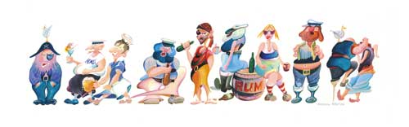
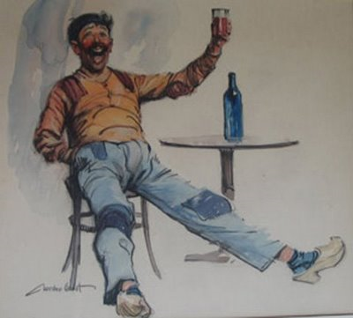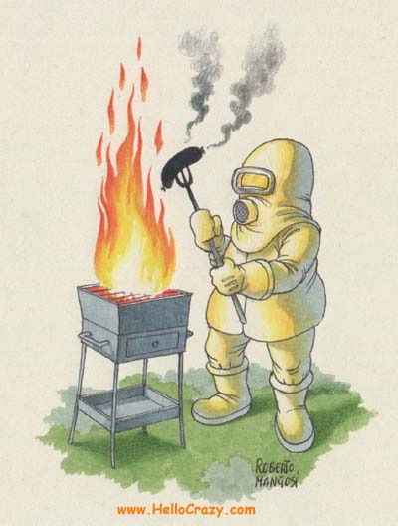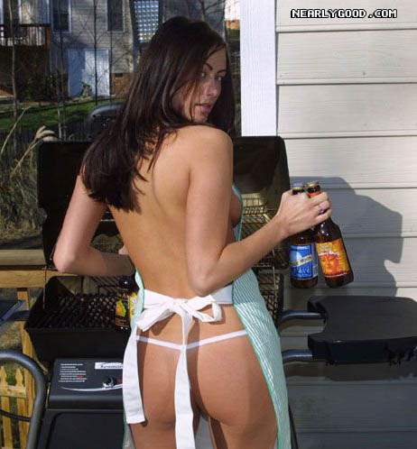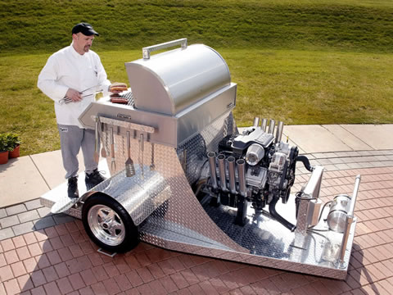

2011 COMBINED ASSOCIATION SUMMER BBQ & SOCIAL

Date, Time & Venue: Saturday 11th June, from 1400 - 1800

at Horsea Island.

Rig: Casual.

Cost: £5 per person incl children

I . . . . . . . . . . . . . . . . . . . . . . . . . . . . . . . . . . . . . (name) will be attending the 2011 combined Association Summer BBQ & Social.
Address/Email:

Telephone No:
I will be bringing the following guests . . . . . . . . . . . . . . . . . . . . . . . . . . (name(s)) . . . . . . . . . . . . . . . . . . . . . . . . . . . . . . . . . . . . . . . . . . . . . . . . . . . . . . . . . . . . . . . . . . . . . . . . . . . . . . . . . . . . . . . . . . . . . . . . . . . . . . . . . . . . . . . . . . . . . . . . . . . . . . . . . .
Car (Make & Registration No.) . . . . . . . . . . . . . . . . . . . . . . . . . . . . . . . . . . . . . . .
Notes.
1. Cheques to be made payable to the ‘MCDOA’.
2. Please indicate if you or your guest(s) are vegetarians.

