CFHTNEWS

No 4, July 2006

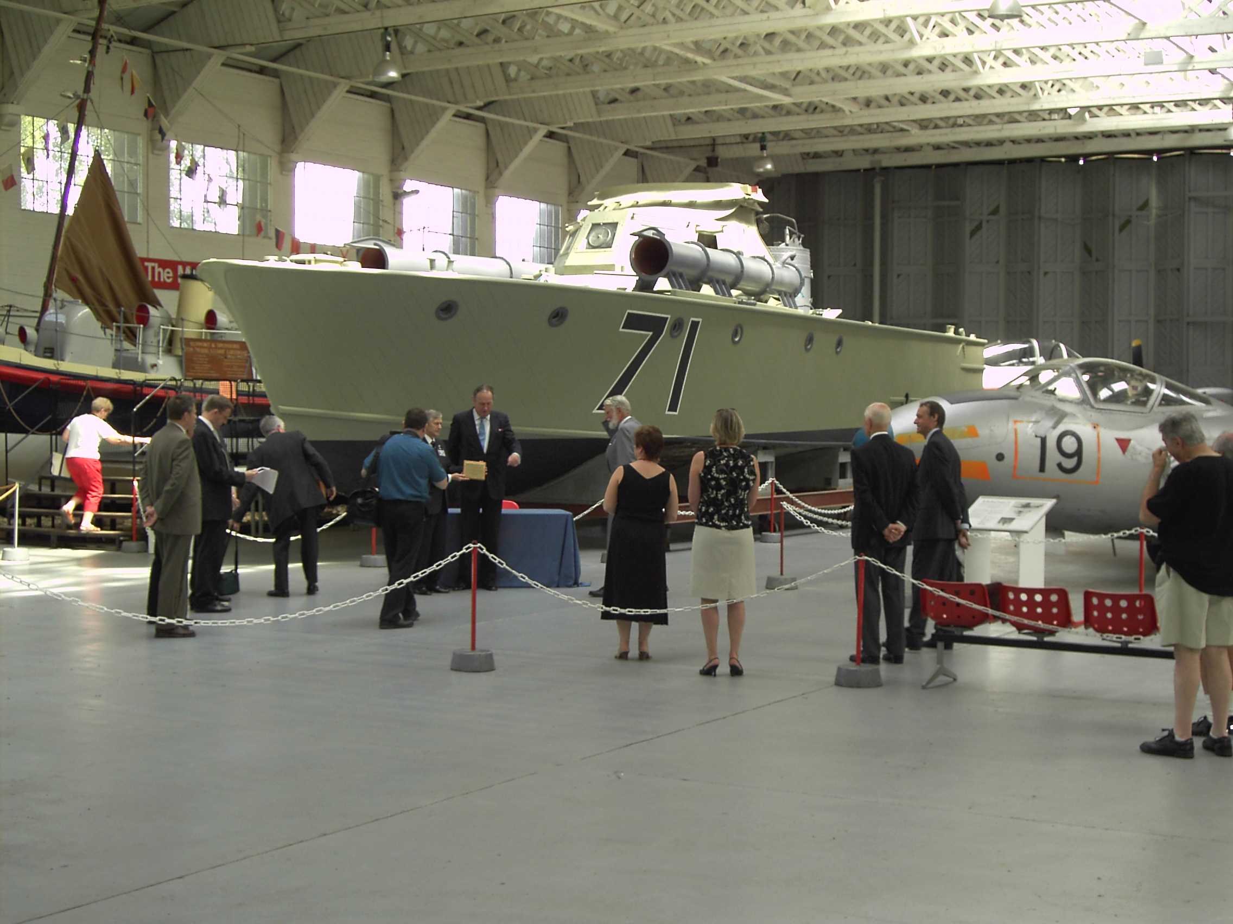

NEWSLETTER

OF

THE COASTAL FORCES HERITAGE TRUST
The Royal Naval Museum, HM Naval Base, Portsmouth, PO1 3NH
02392 724715
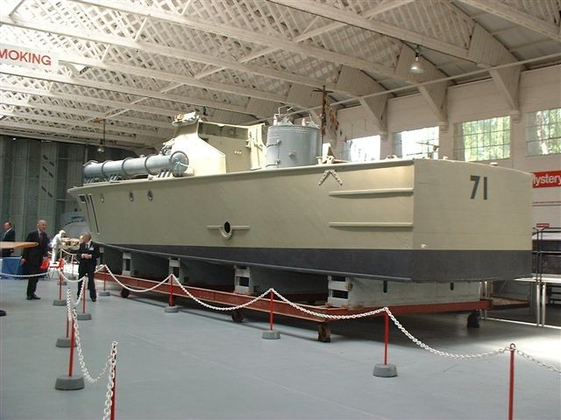

MTB 71 ARRIVES AT DUXFORD. MTB 71, looking very smart in grey livery, has been presented to the Imperial War Museum at Duxford, and was handed over to the Director of the Museum, Mr Robert Crawford who signed the acceptance document from Charles DuCane, Chairman of the British Military Powerboat Trust and The Rt Hon. The Lord Strathcona, the Chairman of the Coastal Forces Heritage Trust. The boat will take the place of MGB 60, sadly destroyed by fire last year. MTB 71 will be a significant addition to the naval display at IWM Duxford and will be sited close to the Lieutenant Agar VC Coastal Motorboat No7 of 1919 Baltic fame, and an X-craft submarine. Refurbishment of the upperdeck of MTB 71 will proceed as money, time and availability of artefacts allow.

CHAIRMAN STEPS DOWN. Lord Strathcona, Chairman since the Trust was started in 1995, has stepped down and as the “Founding Chairman” will become the “President” of the CFHT. His place as Chairman has been taken by Sir Derrick Holden-Brown. Lord Strathcona will remain a Trustee.

OBJECTIVES
The principal objective of the Trust is to have a major presence in the permanent exhibition on

20th and 21st Century naval history, which is planned to be undertaken in the Royal Naval Museum, commencing in the next two and a half years. This is a huge undertaking, which will tax our financial resources, and requires a major fundraising effort. Meanwhile, the Trust maintains a small display in the museum. The current collection of artefacts is held in HMS Hornet, and work continues to archive the photographs and memorabilia which have been kindly donated.

CURRENT ACTIVITIES
The last few months have been busy following the loss of MGB 60 and attempting to negotiate for compensation. It was a satisfactory achievement to negotiate the installation of MTB 71 at IWM Duxford (see above) in place of MGB 60.

MEMORIALS
Our latest project is to become actively involved in establishing commemorative plaques at the locations of the principal former World War 2 Coastal Forces bases, in and around the country. There is one at Lowestoft (HMS Mantis). A memorial plaque was unveiled at Kingswear, Dartmouth (HMS Cicala) on the 10th December, and created much support from local people, and press, TV and radio interest. We are looking at Dover (HMS Wasp), Weymouth (HMS Bee), and Great Yarmouth (HMS Midge). The people of Fort William (HMS St Christopher) are awaiting planning permission to complete a memorial. Research has also reached Malta to investigate possible memorials at HMS Gregale. Coastal Forces Veteran Associations are actively helping, and we intend to fill in the gaps.

COASTAL FORCES VETERANS REUNION
There was a very successful reunion. The guest speaker was Claud Holloway DSC. At the AGM it was decided that next year would be the last and the association would go out with a bang with a week of events 17 to 22 April and thereby prevent an undignified reduction of attendance due to the ever increasing age of members. Details will be published on the website.

REMEMBRANCE SUNDAY
The HMS Hornet Remembrance Service at the Coastal Forces memorial at the Hornet Sailing Centre Gosport is now an established annual event and is well attended by veterans and their families, and also by naval representatives of the Allied and Commonwealth countries that fought in Coastal Forces alongside the Royal Navy.

EXHIBITIONS AND EVENTS
Over the period 1 to 4 July 2005 the Trust had a presence at the International Festival of the Sea at Portsmouth, a major maritime event run in conjunction with the celebrations for the bi-centenary of the battle of Trafalgar – all within “The Year of the Sea”.

HISTORY
Antony Hichens is writing the biography of his father, Lt Cdr Robert Hichens DSO* DSC**and research is proceeding apace.
VIDEO INTERVIEWS
We have now sold 364 copies of video recorded interviews of 36 distinguished CF veterans. The possibility of transfer to DVD is being considered.

RESEARCH MATERIAL. Len Reynolds has amassed a considerable quantity of research material in the course of writing his excellent and popular books on WW2 coastal forces operations. These records have now been put together and on 1st February this year the Imperial War Museum, Lambeth held a reception to receive this invaluable archive of great historical interest. This unique collection will soon be available for all comers in the research field.

VISIT OUR WEBSITE

www.coastal-forces.org.uk

The CFHT website continues to receive “hits” from all over the world, and remains a very cost effective way of promoting the objectives. Watch for details of new Video interviews and available books. We now have over 235 email correspondents. The Trust is not well placed to carry out major research which is manpower and time intensive, but we are trying to overcome this by increasing the website content.

APPEAL FOR FUNDS
Our last appeal raised £5,000. Thank you to all who responded so generously. We need to raise substantial funding towards the RN Museum 20th and 21st Century exhibition and for this the target remains at £50,000. We very much depend on your support - every pound you are able to donate will be of great benefit to the Trust.
WE REALLY NEED YOUR HELP.

Note: We will hold your details on our computer data base for the purpose of record and to contact individuals. If you do not wish your name to be so recorded, please let us know and your details will be deleted.

PRESIDENT The Rt.Hon.The Lord Strathcona and Mount Royal, CHAIRMAN Sir Derrick Holden-Brown,
TRUSTEES
J.Ascoli Esq., J.H.Deeker Esq., R.Ellis Esq., M.Gotelee Esq., A.P.Hichens Esq., Dr.H.C.McMurray, OBE,
L.C.Reynolds Esq. OBE, DSC, DL, Captain T.Robotham, Royal Navy, D.Watson Esq., Commander A.J.W Wilson, Royal Navy.
TRUST SECRETARY
Captain M.C.Gordon-Lennox, Royal Navy
A Company Limited by Guarantee Registered in Cardiff No: 2983847, Registered Charity No. 1044933

