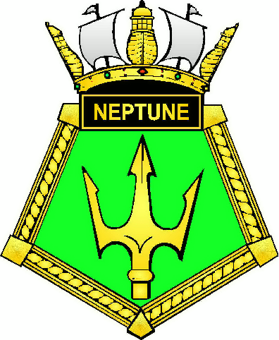
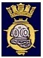

NORTHERN MCDOA ANNUAL DINNER – THURSDAY 3rd MARCH 2016
MCD BRANCH GOLDEN ANNIVERSARY

Time: 1845 for 1930 – 3 March 2016, Pre Dinner Drinks

Venue: The Wardroom, HMS NEPTUNE

Dress/Rig: Mess Undress/Black Tie with miniature medals

Guest of Honour: TBC

                  

I (name) …………………………………………… will attend the 2016 Northern MCDOA Dinner

I would also like to bring (name/s)………………….............................................as my guest/s

I will be arriving by car/taxi (delete as appropriate)

Car Registration ……………………………….

Car Make & Model ……………………………….

Passenger name(s)/arriving with ……………………………….

Any special dietary requirements (vegetarian / nut allergy / gluten free etc)………………………………………

Cheque No.…………… at £30(£35 for non members) per head is enclosed; made payable to:

‘Wardroom Mess, HMS NEPTUNE’

PLEASE RETURN TO OIC NDU2 AND/OR FOST SWOMW1 BEFORE 15 FEBRUARY 2016 (APPLICATIONS AFTER THIS DATE WILL ONLY BE CONSIDERED IN EXCEPTIONAL CIRCUMSTANCES):

Officer in Charge Northern Diving Unit Two, Northern Diving Group, HMNB Clyde, G84 8HL
Or electronically to NAVYPORFLOT-FDSNOICNDU2@mod.uk
Or
FOST MPV SWO Mine Warfare One, Flag Officer Sea Training, HMNB Clyde, G84 8HL
Or electronically to NAVYOPTRG-FOSTNMPVSWOMW1@mod.uk

