All MCDOA Members 13 August 2015
Sirs, Fellow Members,

ASSOCIATION ANNUAL DINNER 2015

This year’s association dinner will be held in HMS Excellent’s Wardroom on Friday 20 November 2015.
We are very fortunate to have as the guest speaker, Vice Admiral Sir Alan Massey KCB, current Chief Executive of the Maritime and Coastguard Agency and previous Second Sea Lord.

The evening will follow the traditional format commencing with pre-dinner drinks in the bar at 1900 followed by food and refreshments and a hearty sing song to the musical accompaniment of the HMS Nelson Volunteer Band before retiring to the bar

The dinner is open to members of the association and their guests only. If a non-member wishes to attend the dinner and is eligible to join the association (serving or retired), then they will be asked to complete the membership process prior to being offered a place at the dinner. WO1 (D/MW) are also welcome to attend as a guest of a member.

The cost of the dinner will be £45 for members and £50 for guests. This will include a welcome drink, four course meal, wine, port and drinks in the bar. Accommodation in HMS EXCELLENT transit block has been reserved so please indicate on your application form if you require a bed allocating.

This year marks the 25th celebration of LMCDO courses '90A & '90B. (Dave Bence, Tony Carruthers (MWO), Graham ‘Griff’ Collins, Nick Davis (MWO), Phil Ireland DSC, John Law, Tim Lewis (MWO), Jim Nisbet, Alastair Stangroom, Jim Tyrwhitt-Drake (MWO), Tony Welch (MWO), Steve 'Steamy' Window and Andrew 'Brigham' Young). Any service leavers (who are paid up members) wishing to be dined out are requested to contact the Hon Sec.Any service leavers (who are paid up members) wishing to be dined out are requested to contact the Hon Sec.

The AGM (details in a separate calling notice) will be held prior to the dinner. Members are encouraged to attend this important serial and make your voices heard to the committee.

Payment can be made by cash, cheque or online bank transfer. Please ensure I receive hard or soft copy application forms by Fri 6th Nov 15.

Looking forward to seeing you all on the night,
Mark
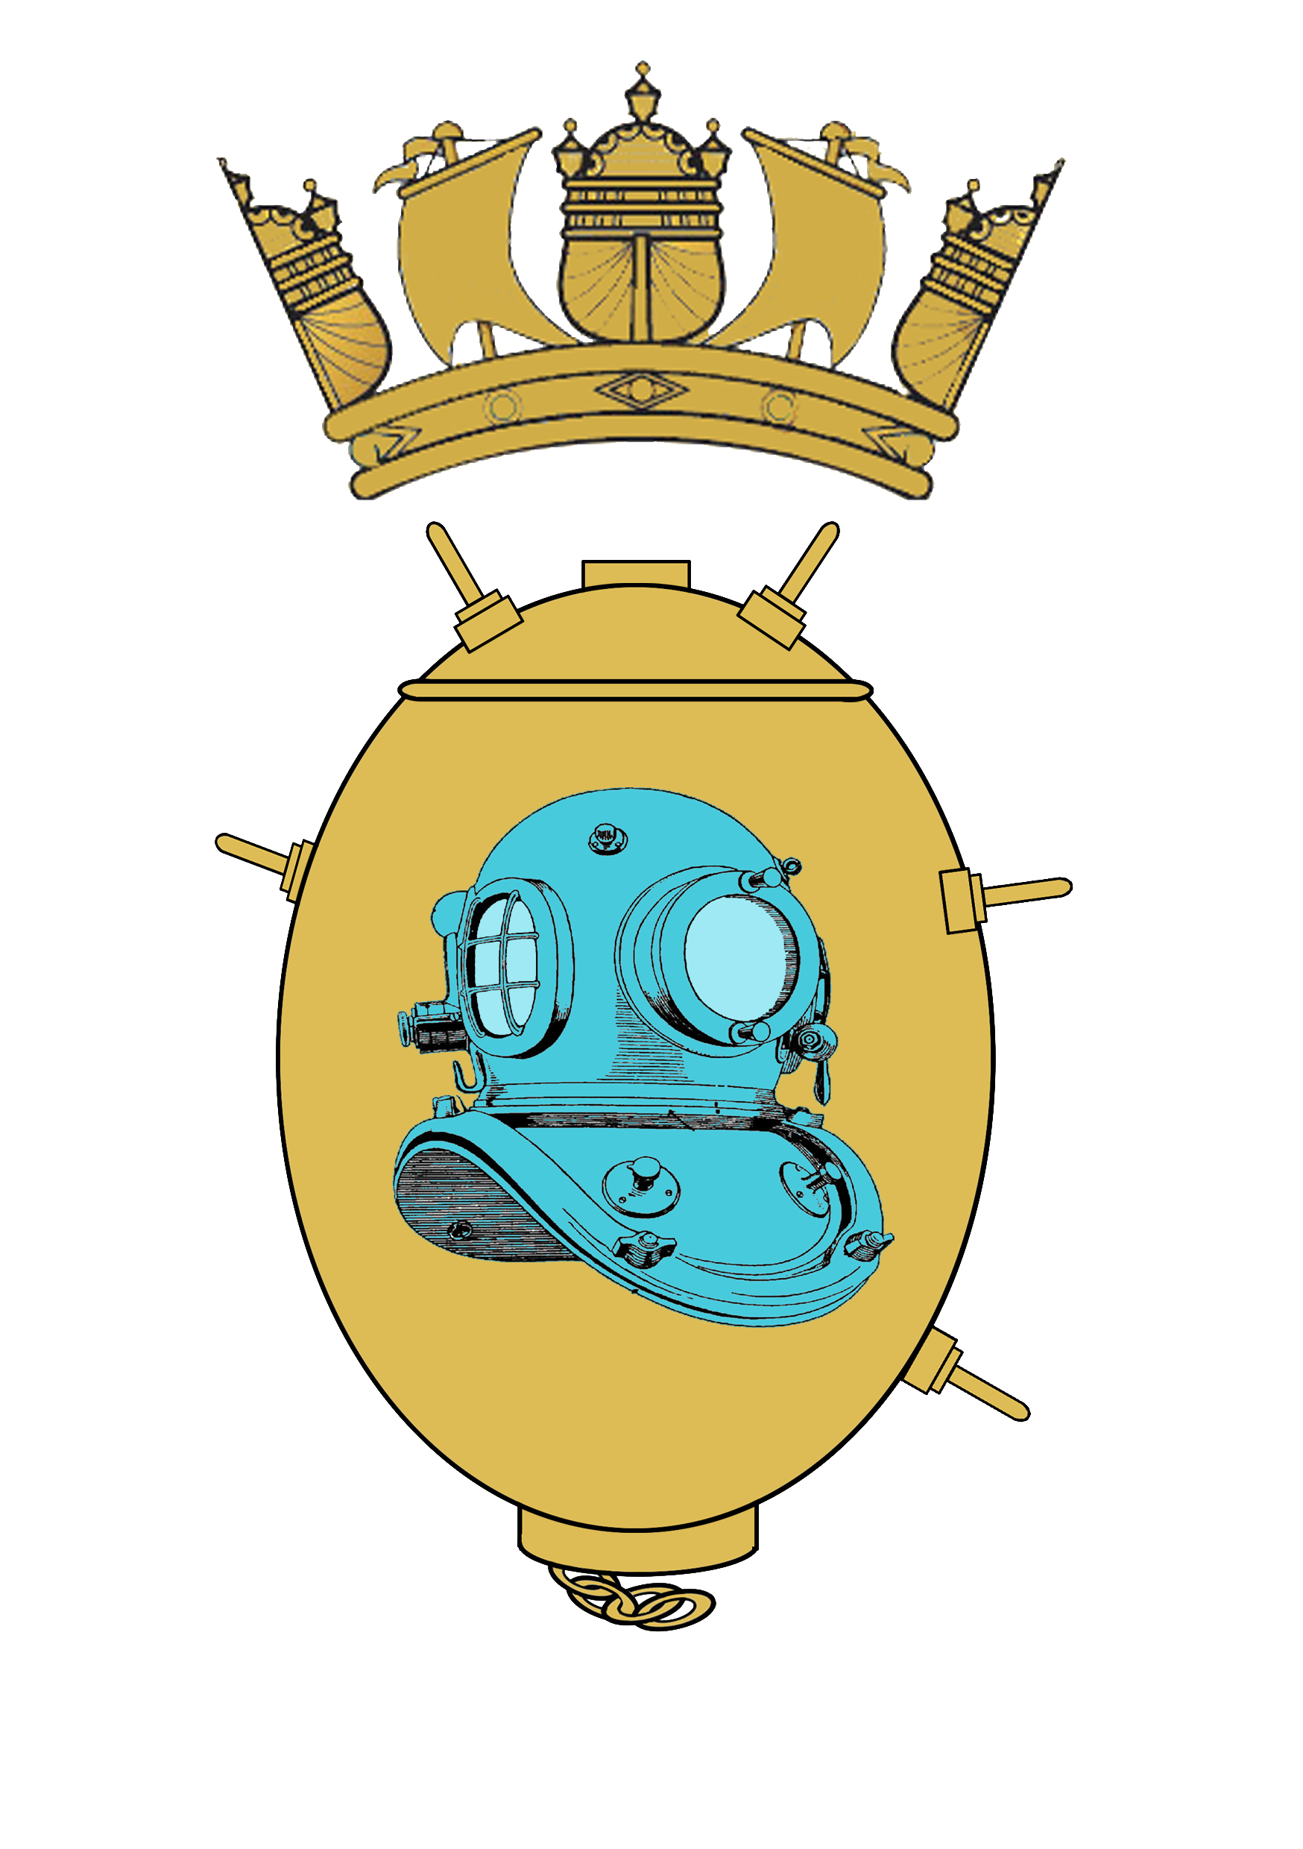
MCDOA ANNUAL DINNER – 2015

Date Friday 20 November 2015
Time: 1900Z
Venue: The Wardroom, HMS Excellent
Dress/Rig: Mess Undress/Black Tie with Miniature Medals
Guest of Honour: Vice Admiral Sir Alan Massey KCB
25th Anniversary Courses: 90A & 90B

Name | Rank | Email | Accom Y/N | Payment: Cash/Cheque/Bank TX
Guests
Total

Details of special dietry requirement:

Cost: £45 MCDOA Members. £50 Guests

Payment: Cheques: made payable to “MCDOA”

Bank Transfer: Account No. 03301885 Sort Code 56-00-64
Ensure you reference the transaction with your “Name” and “Ann Dinner” e.g
“Shaw - Ann Dinner”.

Vehicle Details
Name of Driver | Make | Model | Colour | Reg

Closing date for applications 6 Nov 15.
To be returned to: MCDOA Hon Sec, DSO(N), Bridge Building, Horsea Island, Cosham, Portsmouth. PO6 4TT

