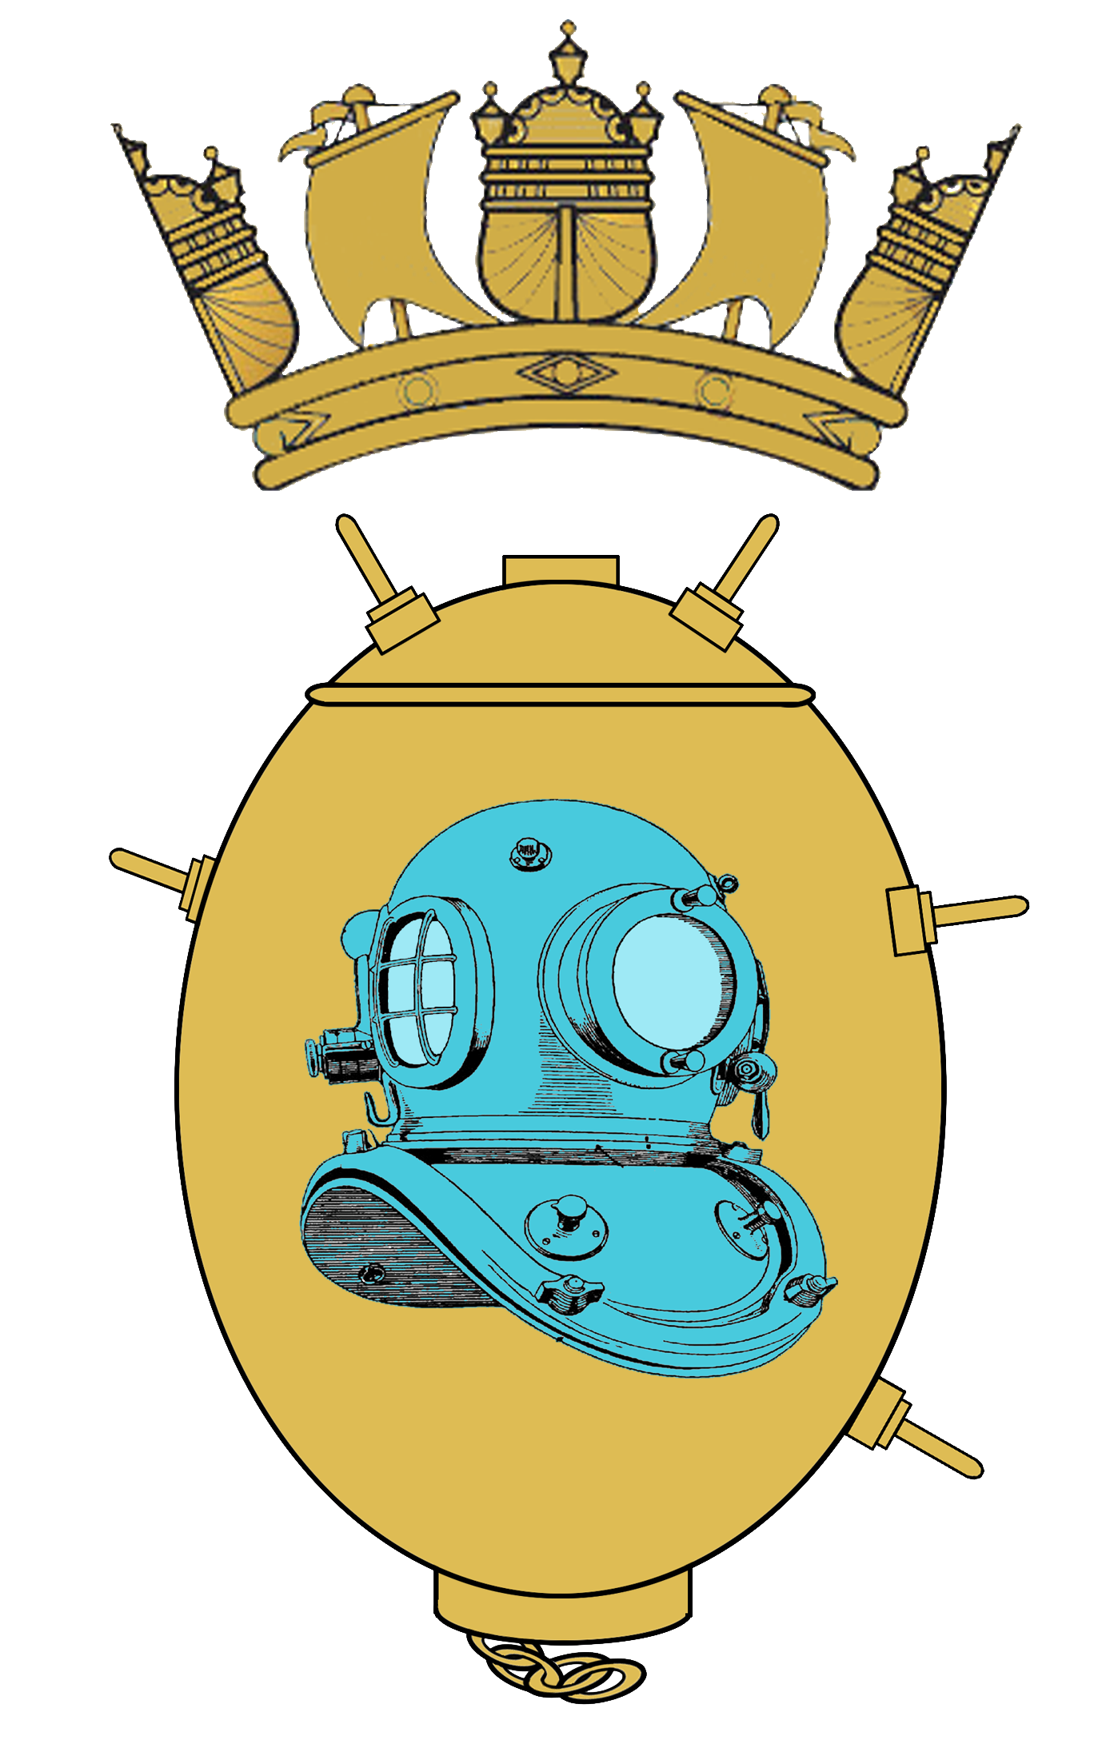  All MCDOA Members | Honorary Secretary  Minewarfare & Clearance Diving Officers Association  Bridge Building  Horsea Island  Portsmouth  P06 4TT  Telephone: 02392 224140  Military: 93832 4140  E-Mail: mark.shaw285@mod.uk  21 October 15

ANNUAL GENERAL MEETING AND OPERATIONAL UPDATE BRIEF – CALLING NOTICE

Date: Friday 20 November 2015

Time: 0930 – 1600

Venue: The Reclaim Theatre, Fleet Diving Headquarter, Bridge Building

AGENDA:

1. Annual Review by the Chairmam

2. Apologies for Absence

3. Agree Previous Minutes

4. Election of Association Committee & Endorsement of Honorary President

5. Matters Arising

6. Amendments to the Association Constitution

7. Financial Statement by the Honorary Treasurer

8. Status of Membership

9. Future Events & Social

10. Any Other Business

11. Chairman's Closing Remarks

12. Date of Next Meeting

Programme:

0930-1000 Members arrive (Tea/coffee available)

1000-1200 Update briefs

SofD – Introduction

Cdr Readwin – Current Ops

Cdr Crosbie – Capability

Cdr Savage – Future Cap

1200-1230 Pre-lunch drinks

1230-1315 Lunch

1330 AGM

o/c Tea/coffee

By 1600 Depart

Those wishing to attend please e-mail Hon Sec at mark.shaw285@mod.uk with name, matters arising and vehicle details (make, model, colour, registration)

